ETL Project

Presented by Cintia, Berenice and Carlos.

Project Introduction

For this project, we use 2 sources of data, both were found on Kaggle:

<https://www.kaggle.com/ihelon/lego-minifigures-classification?select=index.csv>

E: Extract sources

Description: The data source “metadata.csv” is a dataset pulled for lego detail, including: id, name and minifigure name from every product and “index.csv” is a dataset for collection path images for every lego figure.

Files format: csv

Columns used in metadata.csv: class_id, lego_id, lego_name, minifigure_name

Columns used in index.csv: image_id, image_path, class_id

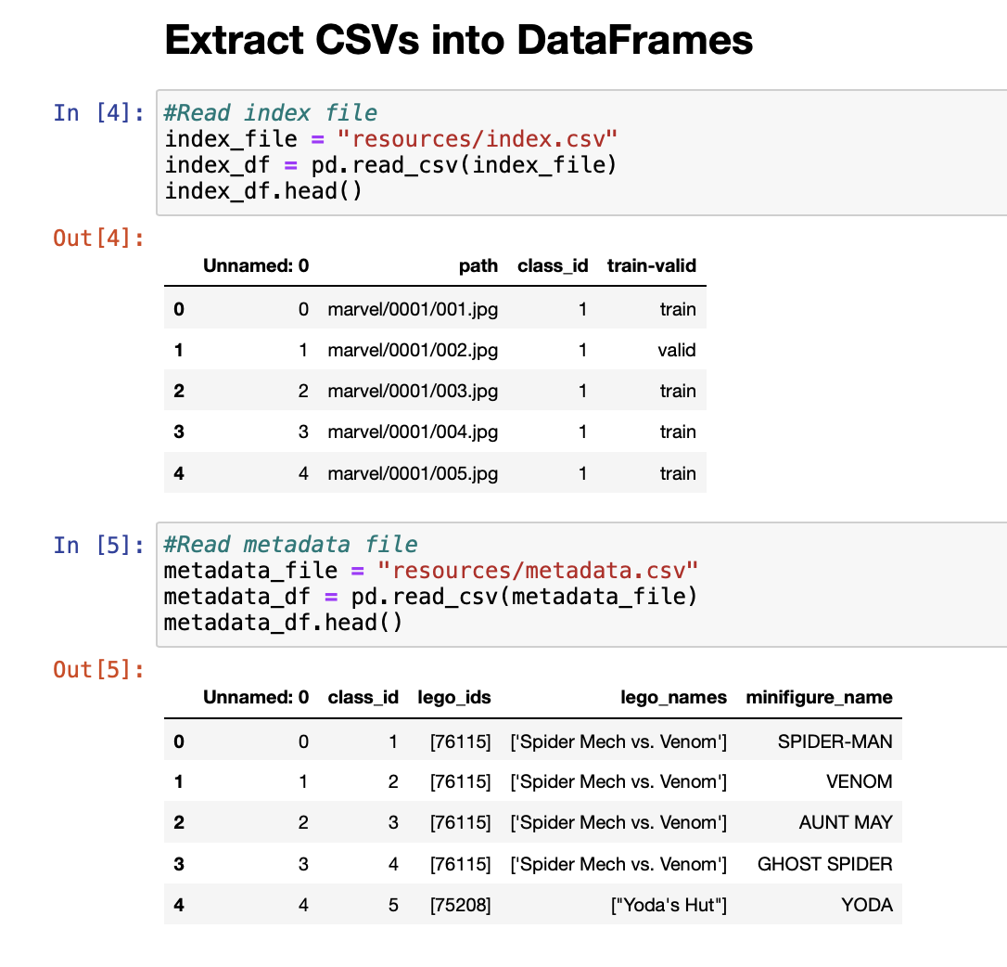

T: Transform

Data was edited and cleaned

Lambda function (apply) was implemented to clean special characters like brackets, double quotes in columns: lego_ids and lego_names.

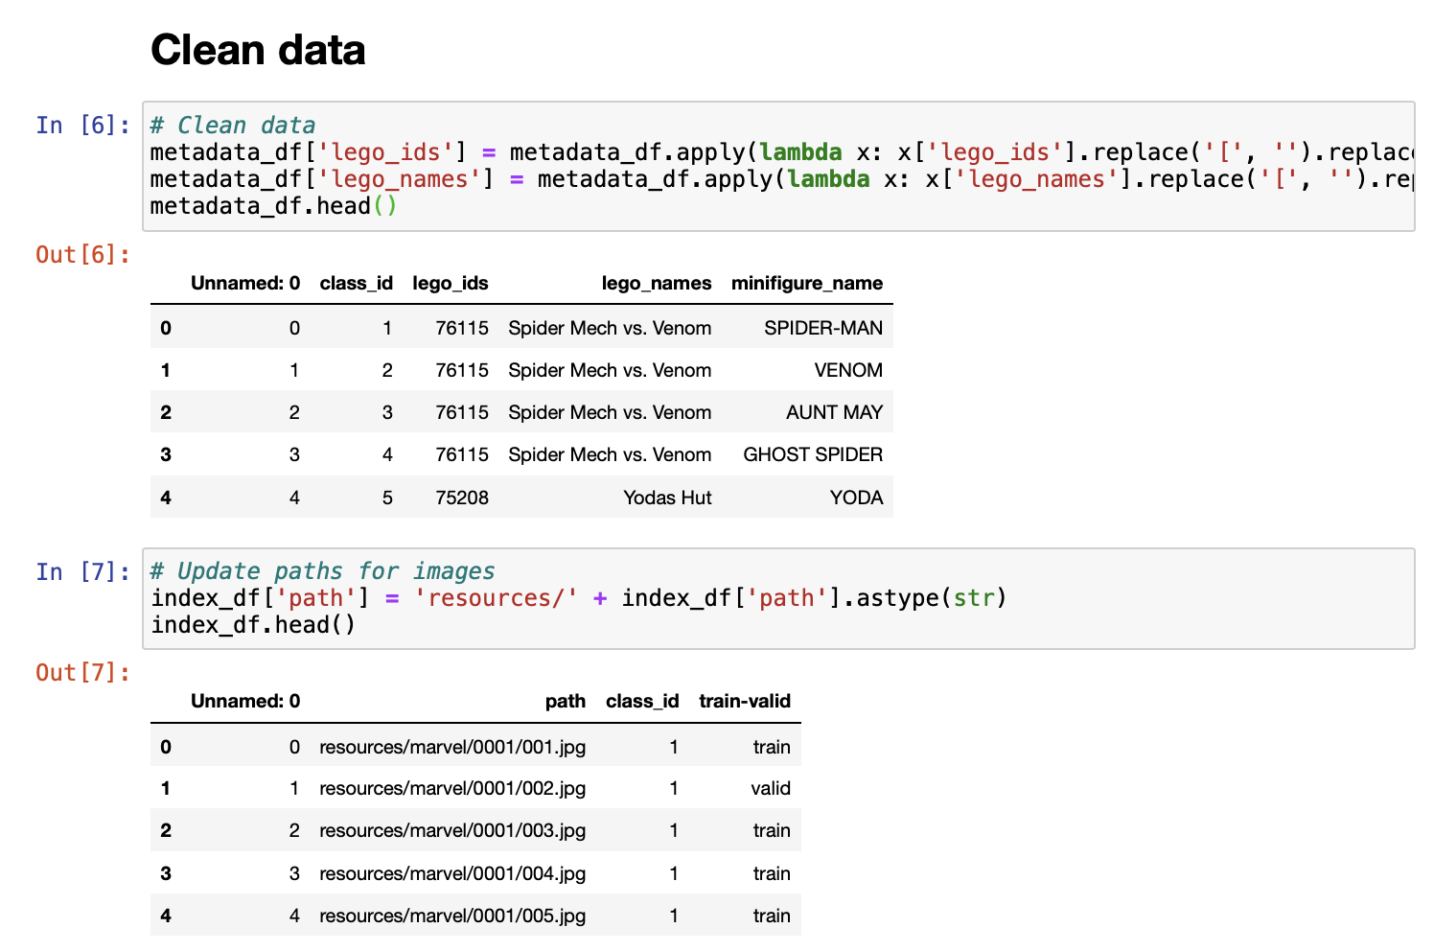

Drop index column that was a sequential numbers for every row in the tables

Pandas library was used to format, remove and edit columns.

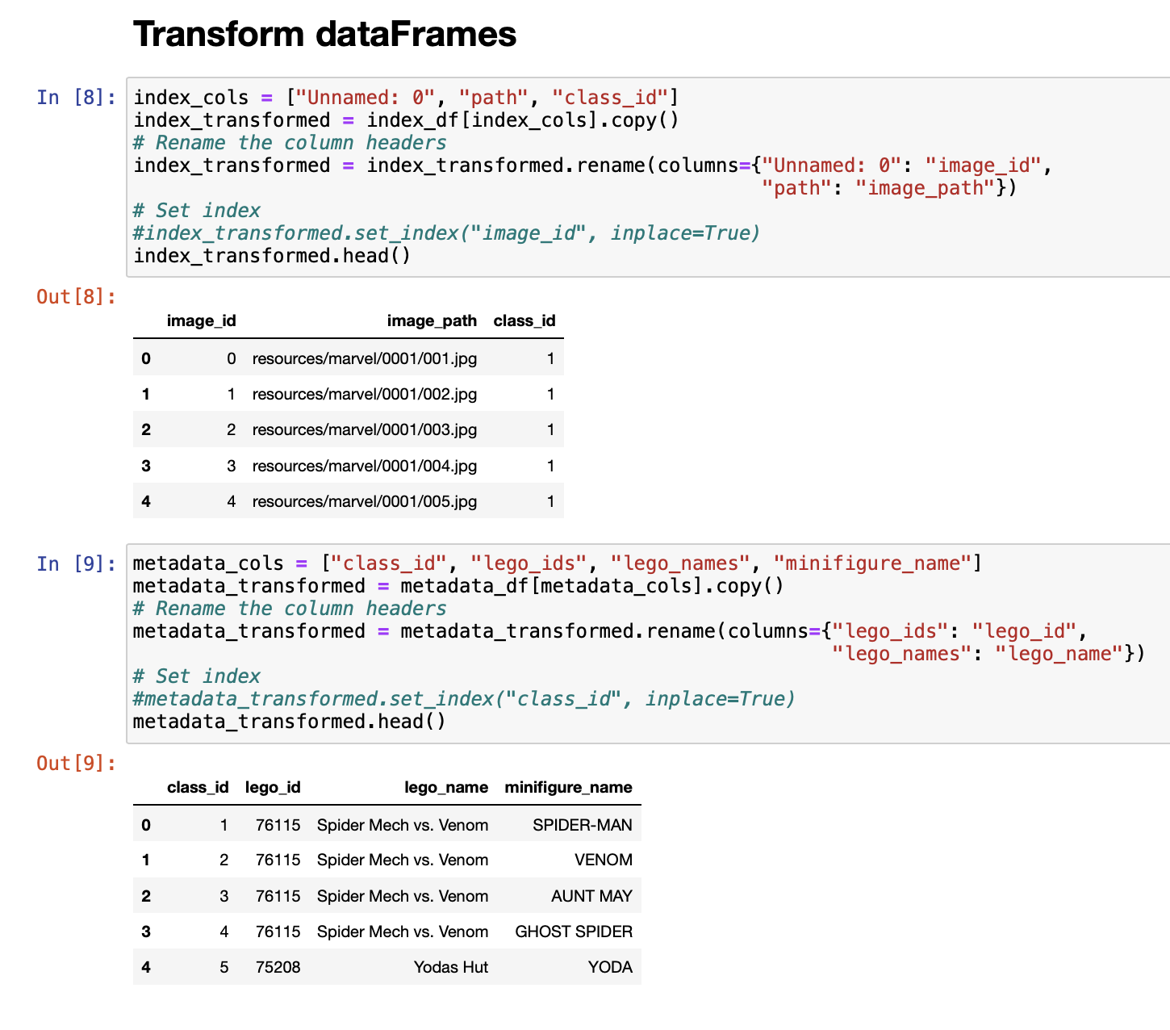

L: Load

Due to the technical challenge that it represents for the members of the team, it was decided to use mongoDB. The final structure of the database is as follows:

**Database name:** **legoDB**

**Collections:**

* **legoCT.**

**Fields:** _ID, CLASS_ID, LEGO_ID, LEGO_NAME, MINIFIGURE_NAME

* **legoIMG**

**Fields:** _ID, CLASS_ID, IMAGE_ID, IMAGE_PATH

Jupyter Notebook was used to create the database connection to mongoDB and transfer data to the non-relational database, aside from creating the collections.

In order to avoid duplicate documents in the database, the collections are dropped each time the process is executed.

Each csv file was written into mongo collections.

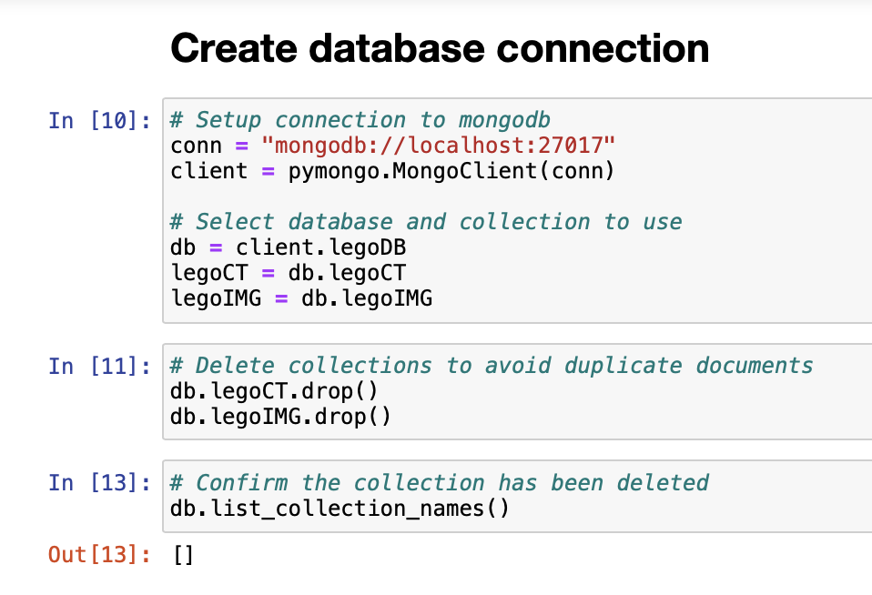

The collections are populated in one go from the dataframes, using the method insert_many.

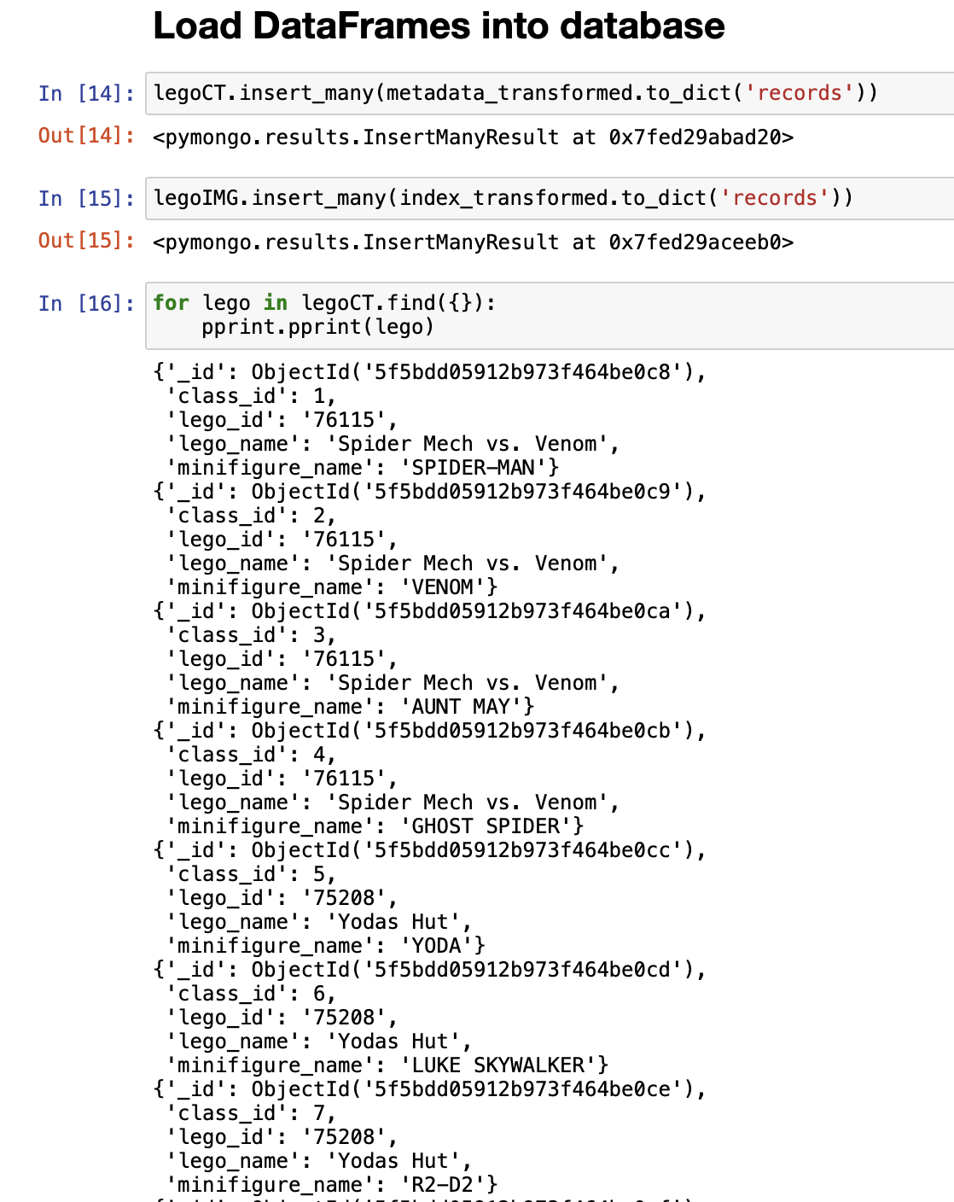

To confirm data load, the find method is used to retrieve all documents for both collections.

